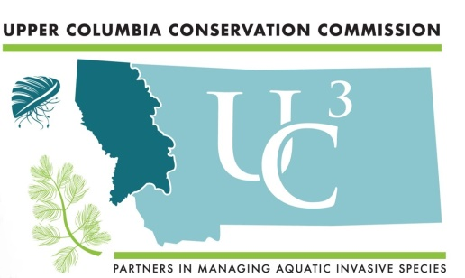

Upper Columbia River Basin Aquatic Invasive Species

2020 Early Detection and Monitoring Plan

February 25, 2020

Contents
1.0 Introduction 1
2.0 Statewide History and Perspective of Aquatic Invasive Species Issue 1
3.0 Role of Upper Columbia Conservation Commission 2
3.1 Members and Partners 2
4.0 Aquatic Invasive Species in the Upper Columbia River Basin 3
4.1 Aquatic Invasive Species of Concern for the Upper Columbia River Basin 4
5.0 Importance of Aquatic Invasive Species Early Detection Monitoring 5
5.1 Management Case Studies 5
6.0 Early Detection Monitoring (2019) 8
7.0 Sample Collection and Equipment Decontamination Protocols 8
8.0 Analytical Laboratories 11
9.0 Recommendations 11
10.0 Emerging Programs, Science, and Technology for Early Detection Monitoring 13
11.0 Literature Cited 14
12.0 Supporting Documents 15
APPENDIX I 16
APPENDIX 2 18

List of Tables & Figures

Table 1. AIS in the Upper Columbia River Basin…………………………………………….. 3

Table 2. AIS of Concern for the Upper Columbia River Basin…………………………………... 4

Table 3. Pounds of Curly-leaf Pondweed Removed from Flathead Lake and River………..... 6

Table 4. Beaver Lake EWM Removal by Suction Dredging Summary………………………… 7

Figure 1: Dreissenid Mussel Invasion Potential Map (Montana FWP)…………….…………………….9

Figure 2. 2019 Upper Columbia River Basin invasive mussel monitoring locations……….… 10

Suggested Citation: Upper Columbia River Basin Aquatic Invasive Species Early Detection and Monitoring Plan (2019). Upper Columbia Conservation Commission, Montana Department of Natural Resources and Conservation, Helena, MT.

1.0 Introduction
This report is a product of the Upper Columbia Conservation Commission (UC³) Early Detection and Monitoring Committee. Montana House Bill 622, Section 6 requires UC³ to monitor the condition of aquatic resources in the tributaries to the Columbia River and coordinate development of an annual monitoring plan. The purpose of this report is to inform future Aquatic Invasive Species (AIS) early detection and monitoring conducted by UC³ and project partners in the upper Columbia River Basin.

Contained in this report are partner sample locations for early detection monitoring efforts from 2019 to provide a framework to guide future prioritization of sampling efforts. The intended outcome of this report is to increase communication amongst project partners to optimize the effectiveness of early detection monitoring and to avoid duplication of efforts.

2.0 Statewide History and Perspective of Aquatic Invasive Species Issue
In 2009, the Montana Legislature passed the Montana Aquatic Invasive Species Act with revisions in the 2011 legislative session for undertaking coordinated educational, prevention, detection and management activities to prevent, detect, control and manage aquatic invasive species.

Prior to 2016, Montana had been one of a few remaining western states void of Dreissenid mussels. However, in early November 2016, the Montana Department of Fish, Wildlife & Parks (FWP) reported that Tiber Reservoir, east of Shelby, Montana, tested positive for Dreissenid mussel veligers. FWP also reported a suspect veliger detection at Canyon Ferry near Helena.

In late November 2016, Governor Bullock issued an executive order declaring a statewide natural resource emergency for Montana waterbodies. The executive order triggered the deployment of an Incident Command Team that worked quickly to identify and contain existing Dreissenid mussel populations and developed plans to prevent further introduction to other waterbodies. In January 2017, the governor disbanded the Incident Command Team and gave responsibility of the AIS effort to the Joint Montana Mussel Response Team, comprised FWP and Montana Department of Natural Resources and Conservation (DNRC), with support from the Montana Invasive Species Advisory Council (MISAC).

The Joint Montana Mussel Response Team developed an implementation strategy for the state of Montana with key sub-category recommendations, including: restrictions, closures, and decontamination; expansion of watercraft inspection stations; expansion of early detection monitoring; strengthening management and program frameworks; and development of a future rapid response plan for invasive species.

In 2017, the Montana Legislature passed HB622 revising laws related to invasive species. Included in HB622 was the creation of the Montana Invasive Species Council (MISC), formerly MISAC. MISC is a statewide partnership working to protect Montana's economy, natural resources, and public health through a coordinated approach to combat invasive species (aquatic and terrestrial). In addition, HB622 created the UC³. MISC and UC³ are administratively attached to DNRC. In 2017, the legislature also passed SB363 that provided a complimentary funding mechanism in the fight against invasive species.

The increased threat of Dreissenid mussels prompted local groups and agencies in or near the Upper Columbia River Basin in 2017 to implement enhanced local AIS programs to compliment efforts at the state level. Included were Glacier National Park, the Blackfeet Nation, the Confederated Salish & Kootenai Tribes, USFWS Creston National Fish Hatchery, Swan Valley Connections, the Clearwater Resource Council, the Blackfoot Challenge, and the Whitefish Lake Institute.

3.0 Role of Upper Columbia Conservation Commission
The mission of the UC³ is to protect the aquatic environment in Montana tributaries to the Columbia River from the threat of AIS in order to protect water resources, downstream interests, and the economic and ecological vitality of the region. UC³ fosters close cooperation and coordination between international, federal, regional, state, tribal, and local water resource managers for the development and implementation of comprehensive Upper Columbia River Basin prevention and management measures to prevent the introduction and/or further establishment of AIS.

3.1 Members and Partners
The UC³ includes 14 voting commission members who are appointed by and serve at the pleasure of the Governor. They include a representative of each of the following:
    - Member at large
    - The Hydropower utility industry
    - Electric cooperatives located within the Columbia River Basin in Montana
    - Conservation districts
    - Private industry
    - Private landowners
    - The Confederated Salish and Kootenai Tribes
    - The Montana Invasive Species Council
    - A Conservation, Natural Resource or hunting/angling organization from the Upper/Middle Clark Fork River Basin
    - A Conservation, Natural Resource or hunting/angling organization from the Bitterroot River Basin
    - A Conservation, Natural Resource or hunting/angling organization from the Flathead River Basin
    - A Conservation, Natural Resource or hunting/angling organization from the Swan/Blackfoot River Basins
    - A Conservation, Natural Resource or hunting/angling organization from the Kootenai River Basin
    - A Conservation, Natural Resource or hunting/angling organization from the Lower Clark Fork River Basin

In addition, the speaker of the house and the president of the senate each appoint two nonvoting members to UC³.
UC³ seeks active input and participation from the U.S. Forest Service, the National Park Service, the U.S. Fish and Wildlife Service, the U.S. Department of Agriculture Natural Resources Conservation Service, the U.S. Army Corps of Engineers, the U.S. Bureau of Reclamation, the Northwest Power and Conservation Council, the Province of British Columbia, and other appropriate entities as deemed necessary. Agency representatives actively participate in UC³ meetings and projects and facilitate coordination and communication between the UC³ and the representative’s organization. In addition, ex-officio members may be recommended by consensus of the Commission. Ex-officio members could include additional representatives of federal entities, local government organizations, tribal governments, Montana universities and private and for-profit organizations with an interest in the wellbeing of Montana pertaining to invasive species with the appointment made by the Governor.

4.0 Aquatic Invasive Species in the Upper Columbia River Basin
AIS include plants, animals, and pathogens that are non-native to an ecosystem. AIS are introduced accidentally or intentionally by human activity outside of their native range. AIS populations can reproduce quickly and spread rapidly because there are no natural predators or competitors to keep their populations in check. Just one organism, or in some cases a piece of a plant, is enough to start a new invasion. AIS can displace native species, clog waterways, impact irrigation and power systems, degrade ecosystems, threaten recreational fishing opportunities, and can cause wildlife and public health problems.

Montana Invasive Species Council (MISC) recognizes the AIS list compiled by FWP, DNRC, Montana Department of Agriculture (MDA), and the Montana Department of Transportation (MDT). Existing AIS species in the Upper Columbia River Basin include five aquatic plants; one mollusk, one pathogen and one amphibian species (see Table 1). Non-native fish are not included in Tables 1 and 2 since they fall under different management guidelines by FWP. FWPs’ Native Fish Management Plan seeks to: monitor the presence, distribution and abundance of Montana's native fish; maintain or enhance Montana's native fish populations and habitats; and encourage participation by Montana's scientific community, other state and federal agencies, and local communities to conserve and enhance our native fish populations and habitats.

Table 1. AIS in the Upper Columbia River Basin.
AIS | Major River Drainage | Waterbody
American bullfrog (Lithobates catesbeianus) | Flathead | Flathead River
Snapping Turtles  (Chelydra Serpentina) | Flathead (native to eastern MT) | Flathead Lake
Purple loostrife  (Lythrum salicaria) | Blackfoot | Clearwater River
New Zealand mudsnail  (Potamopyrgus antipodarum) | Bitterroot | Private hatchery @ Hamilton
Fragrant Waterlily  (Nymphaea odorata) | Blackfoot | Browns Lake  Lake Inez  Seeley Lake  Salmon Lake  Upsata Lake*
 | Flathead | Beaver Lake  Lake Mary Ronan
 | Kootenai | Duck Lake  Savage Lake
 | Swan | Holland Lake*
Yellowflag Iris  (Iris pseudacorus) | Flathead | Whitefish Riverside Stormwater Pond*  Whitefish River*  Blanchard Lake
 | Clark Fork | Missoula irrigation canal
 | Bitterroot | Bitterroot River
 | Blackfoot | Salmon Lake*  Clearwater River*
Flowering Rush  (Butomus umbellatus) | Clark Fork | Clark Fork River (lower), including;  - Noxon Reservoir  - Cabinet Gorge Reservoir
 | Flathead | Flathead River (upper)  Flathead River (lower)  Flathead Lake
Eurasian Watermilfoil  (Myriophyllum spicatum) | Clark Fork | Clark Fork River (lower), including;  - Noxon Reservoir  - Cabinet Gorge Reservoir
 | Flathead | Beaver Lake
Curly-leaf Pondweed  (Potamogaton crispus) | Bitterroot | Bitterroot River
 | Clark Fork | Clark Fork River (middle and lower), including;  - Noxon Reservoir  - Cabinet Gorge Reservoir
 | Flathead | Flathead River (lower), including;  - Kicking Horse Reservoir  - Ninepipe Reservoir  - Pablo Reservoir  Flathead Lake
Faucet Snail  (Bithynia tentaculata) | Blackfoot | Upsata Lake*  Browns Lake
 | Clark Fork | Georgetown Lake*
 | Flathead | Flathead River, including;  - McWennegar Slough  Flathead Lake*  Smith Lake
Whirling Disease  (Myxobolus cerebralis) | Bitterroot  Blackfoot  Clark Fork  Kootenai | N/A
*Waterbodies either not listed for a species or not consistently reported by FWP and the Montana Natural Heritage Program.

4.1 Aquatic Invasive Species of Concern for the Upper Columbia River Basin
There are a number of AIS of concern for the Upper Columbia River Basin and the state of Montana. Table 2 displays AIS that pose a higher risk potential to colonize and cause further environmental and economic impact to state waters. It is a prioritized watch list but does not include all AIS that have the potential to be transported to, or to colonize Montana waters.

Table 2. AIS of Concern for the Upper Columbia River Basin.
 | Present in Montana | Detected in Montana | Undetected in Montana
Crustaceans |  |  | Spiny Waterflea  Fishhook Waterflea  Rusty Crayfish
Mollusks | Faucet Snail*#  New Zealand Mudsnail* | Red-Rim Melania  Quagga Mussel  Zebra Mussel | Asian Clam  Chinese Mysterysnail
Parasites & Pathogens | Whirling Disease* | IHN Virus | Asian Tapeworm  Microsporidian Parasite  VHS Virus
Plants | Eurasian Watermilfoil*  Flowering Rush*  Curly-leaf Pondweed*  Fragrant Waterlily*  Yellowflag Iris* |  | Hydrilla  Brazilian Elodea  Parrotfeather Milfoil  Yellow Floating Heart
*Present in the Upper Columbia River Basin.
#Waterbodies either not listed for a species or not consistently reported by FWP and the Montana Natural Heritage Program.

5.0 Importance of Aquatic Invasive Species Early Detection Monitoring
Once established, there are currently few, if any, methods to effectively control or eradicate AIS in natural waterbodies. Control methods require continued maintenance over time and often become cost prohibitive. Nationwide, there are very few AIS eradication success stories, and those that are successful are often due to unique environmental circumstances or special management options.

If AIS are detected during an early detection and monitoring program, managers have more options to implement rapid response strategies for control and containment efforts. Aggressive rapid response strategies can lead to effective containment in a waterbody and reduce the transport risk potential to other waters. The following AIS control effort case study examples in the Upper Columbia River Basin range in the time from onset of colonization to when control efforts began, along with the mitigation technique.

5.1 Management Case Studies

Case Study 1- Flowering Rush in Flathead Lake
Flowering Rush is the oldest known AIS in the Upper Columbia Basin, first collected in Montana along the north margin of Flathead Lake in 1962. From Flathead Lake, Flowering Rush has also spread 12 miles upstream of where the Flathead River enters the lake, and 165 miles downstream, into the Clark Fork River and all the way to Lake Pend Oreille in Idaho. Flowering Rush has affected more than 2,000 acres of Flathead Lake. It’s estimated that it has the capability of invading 75 percent of Flathead's littoral zone, and as many as 12,000 of the lake's 124,000 surface acres, or nearly 10 percent of Flathead's currently open waters. Flowering rush is established below the ten foot drawdown zone to depths of twenty feet, but the extent us unknown.
Researchers from Salish Kootenai College (SKC) and The University of Montana have found that registered aquatic herbicides can suppress flowering rush top growth up to 90% through the growing season, and after five years of annual treatments the reproductive rhizome has been reduced up to 80%. They are also testing water column injections, where computer-controlled weighted hoses pulled behind a boat inject precise amounts of herbicides. Staffing availability, treatment costs, and the infestation magnitude have hindered control and eradication efforts.
Case Study 2- Curly-leaf Pondweed in Flathead Lake
The Flathead Basin Commission commissioned a report by Weed Management Services in 2015 to analyze Curly-leaf Pondweed (CLP) in Flathead Lake and the Flathead River. A second draft of this report exists but it is unclear if a final report was published. Curly-leaf Pondweed was first discovered in the Upper Columbia River Basin in Ninepipe Reservoir in 1974. Surveys conducted from 2010 to 2015 show only three sites as infested in Flathead Lake, including Lakeside, North Shore, and Bigfork Condominium Marinas. It is estimated that at least 5,000 acres in Flathead Lake are susceptible to colonization. In the Flathead River, Curly-leaf Pondweed is scattered from the mouth of the river upstream 12 miles.

Methods used in Curly-leaf Pondweed control efforts include diver dredge removal and herbicide application. Control effort results for Flathead Lake and the Flathead River from 2013-2015 are found in Table 3.

Table 3. Pounds of Curly-leaf Pondweed Removed from Flathead Lake and River.
Site | Year
 | 2015 |  | 2014 |  | 2013
 | lbs FW* removed | % removed | lbs FW removed | % removed | lbs FW removed | % removed
Lakeside | 297 | 90 | 486 | 90 | 95** | --
Bigfork | 153 | 90 | 252 | 80 | -- | --
Flathead River | -- | -- | 329 | -- | 323 | --
Fennon Slough | -- | -- | 120 | -- | 222 | --
*FW=fresh weight of aquatic plants
** In 2013, CLP removal in Lakeside only occurred outside the break-wall due to lack of landowner permission.

Case Study 3- Eurasian Watermilfoil in Noxon and Cabinet Gorge Reservoirs
Eurasian Watermilfoil (EWM) was discovered in Noxon Reservoir in 2007. Initial plant surveys revealed 247 acres of dense EWM in Noxon Reservoir and 117 acres of dense EWM in Cabinet Gorge Reservoir. In response to this discovery, the Sanders County Aquatic Invasive Plants Task Force (Task Force) was formed in 2008. The Task Force is charged with managing aquatic invasive plants in Sanders County waterways.

Herbicide demonstrations to control EWM were conducted from 2009 to 2011. Based on these demonstrations, programs to control EWM were implemented in Noxon Reservoir (2010, 2012-2016) and Cabinet Gorge Reservoir (2014-15). As a result, dense EWM areas were reduced by 98% in Noxon Reservoir, and 77% in several Cabinet Gorge Reservoir sites through 2014. Throughout this time period, both reservoirs continued to support diverse communities of native plants. In 2015, extremely low run off and high temperatures began earlier than normal and continued through the summer. This situation created favorable growing conditions for EWM and led to the acreage of dense EWM in Noxon Reservoir climbing from 24 acres in the fall of 2014 to almost 150 acres in spring 2015. Herbicide treatment of EWM did not occur in either reservoir in 2017.

In 2017, a treatment plan was developed by the Task Force under guidance from a Scientific Advisory Panel for treatments in future years. This an analysis of treatment alternatives for EWM was conducted to examine the various options for managing EWM in Noxon and Cabinet Gorge reservoirs. The analysis examined different methods for treatment to reduce dense EWM coverage and prioritization of treatment areas. Ultimately, chemical and mechanical methods were deemed most appropriate given the conditions in the reservoirs. Public or residential use sites (e.g., boat launches, docks, swimming areas) were given the highest priority for treatment with large, high density shallow areas with substantial boat traffic being given secondary priority. In 2018 and 2019 treatment in Noxon and Cabinet Gorge reservoirs was focused on these high priority areas. Treatment consisted of using endothall and diquat on 30.9 acres across the two reservoirs in 2018. In 2019, 75.4 acres were treated with endothall and diquat across the two reservoirs. In addition, 22.9 acres on Noxon Reservoir were treated on a trial basis with a new herbicide called ProcellaCOR.

In addition to treatment, genetic testing of milfoil plants has occurred on Noxon Reservoir. Results indicate that hybrid watermilfoil exists there. Little research has been conducted on these hybrid strains and how best to treat them, increasing the difficulty of managing invasive watermilfoil in these reservoirs. Other components of the EWM management program developed on Noxon and Cabinet Gorge reservoirs includes educational outreach to increase public awareness and teach plant identification, and assistance with the placement of bottom barriers at key public boat ramps and public and private docks. Funding to support the EWM management program on Noxon and Cabinet Gorge reservoirs has been provided by Avista through the Clark Fork Settlement Agreement and grants from DNRC and the U.S. Army Corps of Engineers.

Case Study 4- Eurasian Watermilfoil in Beaver Lake
After EWM was discovered at the Beaver Lake boat ramp in 2011 by DNRC staff, an ad-hoc committee comprised of interested parties formed to address the issue, including; the Flathead Basin Commission, Flathead County Weed District, MDA, DNRC, FWP, and the Whitefish Lake Institute (WLI).

The initial management effort included the placement of bottom barriers at the infestation site. The bottom barriers proved effective in eradicating the majority of the localized population near the boat ramp, however, smaller, scattered EWM populations near the boat ramp and along the western shoreline remained.

Since 2012, WLI has recommended an AIS Management Plan to the City of Whitefish that includes control/eradication suction dredging efforts for EWM at Beaver Lake. Whitefish has prioritized this effort due to the proximity of Beaver Lake to Whitefish Lake, including hydrologic connectivity. Suction dredge efforts to control EWM in Beaver Lake have been highly effective. Suction dredging involves a diver identification survey of single plants or plant communities and then suction dredging the plants from the roots to prevent fragmentation. WLI also deploys and maintains a sediment curtain owned by the Flathead Lakers near the lake outlet to Beaver Creek to prevent downstream drift of any plant fragments. WLI will recommend that suction dredging continue in Beaver Lake indefinitely.

Table 4. Beaver Lake EWM Removal Summary by Suction Dredging Summary.
Year | EWM Removed (FW/lbs)* | Number of Plants
2012 | 23.5 | No data available
2013 | 5 | No data available
2014 | <1 | No data available
2015 | <1 | 15
2016 | <0.25 | 5
2017 | <0.25 | 2
2018 | 0 | 0
2019 | No weight data available | Several hundred individual plants
*FW=fresh weight

In June 2019, EWM plants were again found near the boat ramp by a FWP survey crew. FWP and WLI partnered in a suction dredge operation to remove plants and bottom barriers were placed over the impacted area. It appears that some plants are at depths that will require a dive team to mitigate.

Although some EWM remains present in Beaver Lake, the potential for Beaver Lake EWM population to be the parent source for other waterbodies is substantially reduced due to the control effort.

6.0 Early Detection Monitoring (2019)

Figure 1 displays AIS early detection monitoring locations in the Upper Columbia River Basin by sample type in 2019. Partners have used plankton tows (microscopy analysis) as the primary early detection tool and it is the standard recognized by FWP. Increasingly, partners have collected environmental DNA (eDNA) samples. Other early detection and monitoring tools include the deployment of artificial substrates and ocular surveys around boat ramps and other prioritized shoreline areas. Citizen scientist volunteers are often the eyes in the field for their local lake. An example of an existing AIS-related citizen scientist program in the Upper Columbia River Basin is the Northwest Montana Lakes Volunteer Monitoring Network (NWMTLVMN). See Section 10 for sampling and other recommendations for the Upper Columbia River Basin.

7.0 Sample Collection and Equipment Decontamination Protocols
Sample collection protocols often vary by partner due to funding availability, staffing levels, and environmental conditions. Project partners should use the FWP AIS Management Program Field Sampling and Laboratory Standard Operating Procedures (2019), or the Western Regional Panel on Aquatic Nuisance Species Sampling and Monitoring Protocol (2018) as a starting point for their specific program needs. eDNA monitoring procedures should follow lab-specific protocols. The Flathead Lake Biological Station, University of Montana (FLBS) can provide protocols for invasive mussel eDNA sample collection. The reports cover sample collection and equipment decontamination protocols. Partners should communicate with their receiving analytical laboratory for any special instructions, including sample preservation. FWP has also developed an AIS sampling data application (app) that is available to partners to encourage consistent and timely data collection. FWP is developing a training program for partners interested in AIS survey and sampling efforts. The training reviews AIS survey and sample collection protocols for invasive mussels, weeds, clams, snails and crayfish.

Dreissenid mussel habitat suitability is based on many factors, including calcium, pH, alkalinity, and temperature. Western jurisdictions often use calcium data as a predictor of potential mussel invasion, including the state of Montana (see figure XX below). The majority of lakes within the Upper Columbia Basin fall within the tolerance threshold for invasive mussel habitation if calcium is analyzed independently. Although there is much variability in calcium concentrations between lakes, it is evident that the overall risk-based habitat suitability is high. Determining lakes that are most suitable for zebra/quagga mussels will be especially important in making management decisions unique to each lake, especially if an infestation occurs. Alkalinity concentrations for all program lakes meet the minimum requirement of 18 mg/L for zebra/quagga mussel habitation (Northwest Montana Lakes Volunteer Monitoring Network 2018 Annual Report). Calcium data will be collected in the 2021 season and incorporated in a future iteration of the Upper Columbia Basin AIS Early Detection & Monitoring Plan.
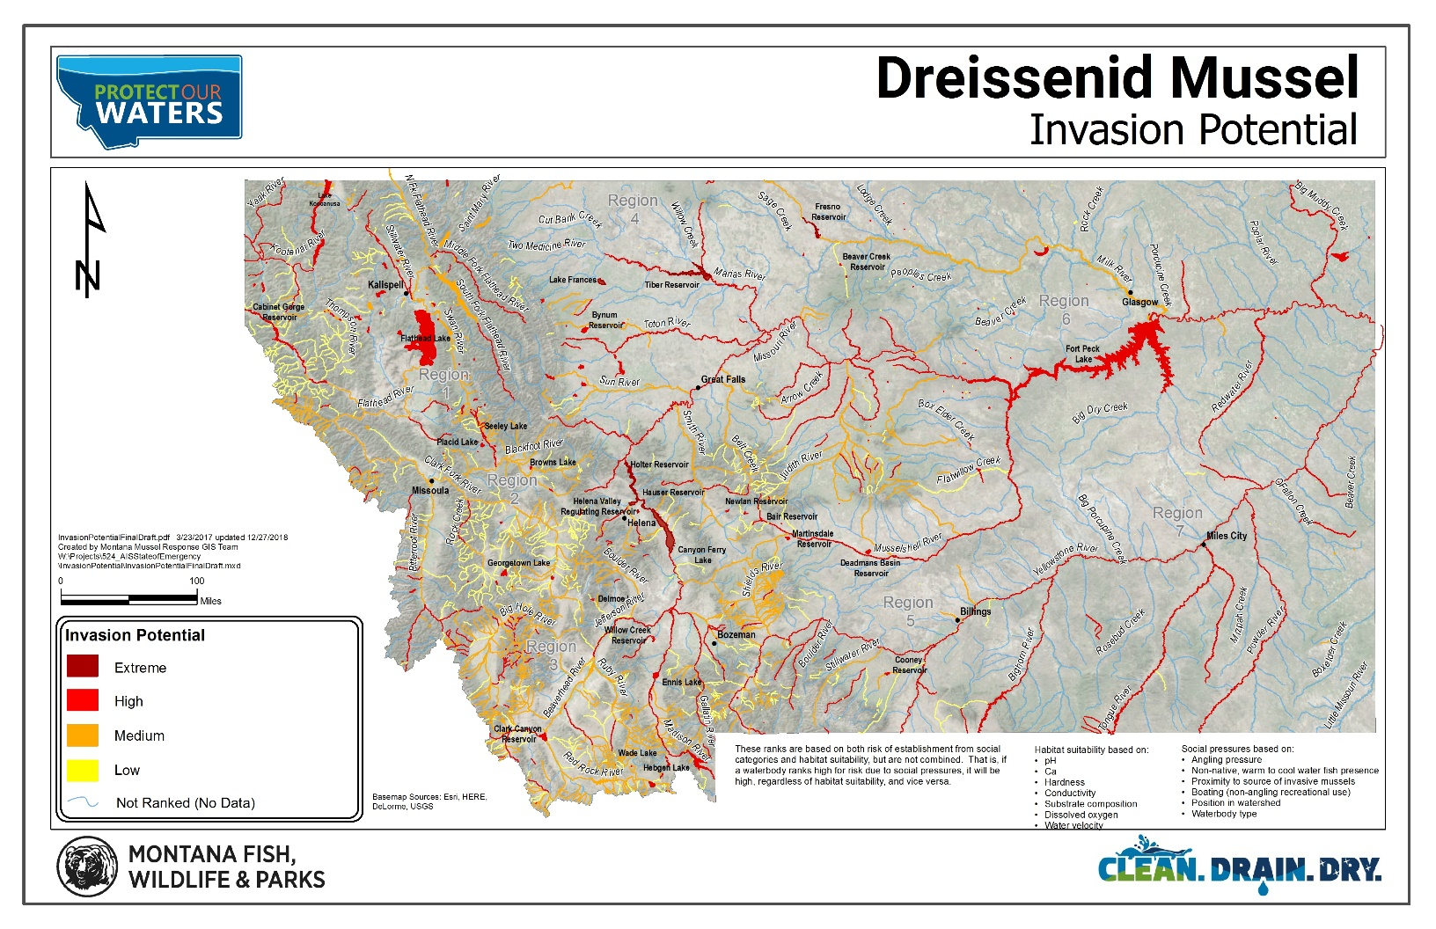
Figure 1 (above). Dreissenid Mussel Invasion Potential Map (Montana FWP and DNRC).

In April 2018, a six-person panel of AIS eDNA experts were assembled by MISC to evaluate the use of eDNA for Dreissenid mussel early detection and provide input and guidance to managers regarding its use in Montana. Key findings from that panel discussion are found in Appendix I. Further information can be found at CleanDrainDryMT.com.

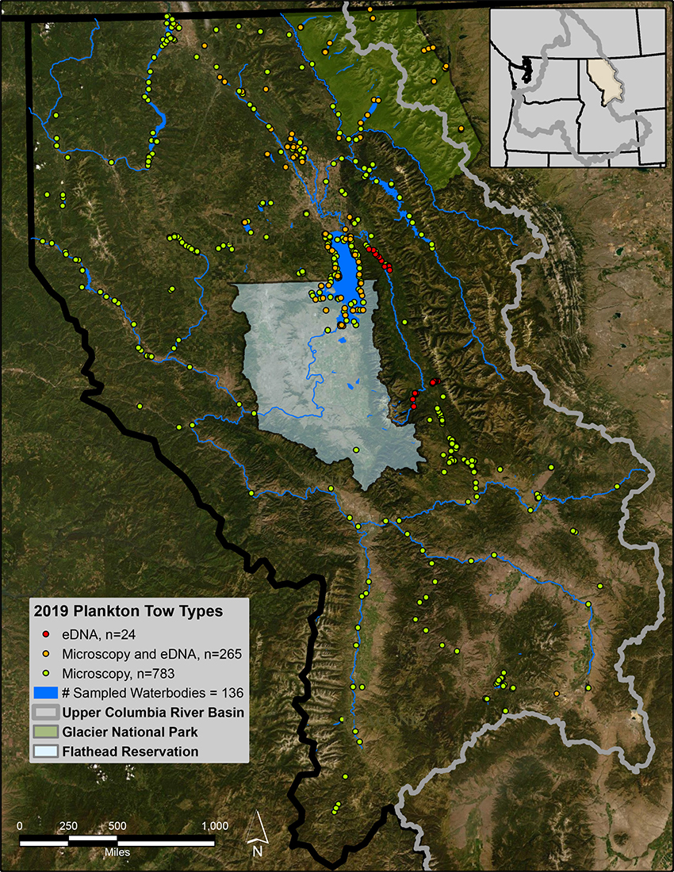
Figure 2 (above). 2019 Upper Columbia River Basin invasive mussel monitoring locations (courtesy Phil Matson, The University of Montana, Flathead Lake Biological Station).

8.0 Analytical Laboratories
Project partners in the Upper Columbia River Basin have used the FWP AIS laboratory in Helena for microscopy veliger detection. The lab processes early detection samples free of charge.

Other laboratories that provide microscopy Dreissenid veliger early detection analysis include:
- EcoAnalysts Labs, Moscow, Idaho
- US Bureau of Reclamation Technical Services Center, Denver, Colorado

For eDNA samples, project partners have used the University of Montana Conservation Genetics Laboratory (MCGL) for analysis. The AIS assay list at MCGL includes; two Dreissenid genus specific, two zebra species specific, one quagga species specific, Dreissenid versus native mollusks KASP assay (not quantitative), Eurasian watermilfoil vs native milfoil KASP assay (not quantitative), curly leaf pondweed, and New Zealand mudsnail.

Other eDNA labs can provide this service or serve as independent verifiers. A partial list includes:
- USGS Laboratory- LaCrosse, Wisconsin
- Murdock Laboratory, University of Montana Genomics Core Facility- Missoula, Montana
- Pisces Molecular Lab- Boulder, Colorado
- Portland State University- Portland, Oregon
- US Bureau of Reclamation Technical Services Center, Denver, Colorado

9.0 Recommendations

An objective of this report is to identify AIS early detection and monitoring data needs in the Upper Columbia River Basin. Figure 1 of this report provide an excellent spatial representation of early detection and monitoring efforts from 2019 and a basis to inform a discussion between project partners to fill data gaps where needed. Recommendations identified by the UC³ Early Detection and Monitoring Committee include;

- Comment on FWP Field Sampling and Laboratory Standard Operating Procedures
The UC³ Early Detection and Monitoring Committee should review and provide comments and recommendations to any updates to the FWP field sampling and laboratory standard operating procedures where warranted.

- Annual Early Detection and Monitoring Coordination Meeting and Training
The UC³ should coordinate on an annual basis, in mid-winter, an annual early detection and monitoring coordination meeting with project partners. The purpose of this meeting would be to review the previous year’s sampling efforts and results and identify areas in need of sampling (or increased frequency/intensity of sampling sampling). The annual coordination meeting should be followed by several FWP led trainings around the basin in early spring to provide consistency in sample collection amongst partners.

- Database Expansion & Use of Data Application
UC³ recommends continued refinement and development of the FWP AIS database. In 2017, FWP developed an AIS and water quality monitoring application (app) to facilitate accurate and consistent data collection amongst participating groups. In 2018 and 2019, select partners were asked to use the app for testing and use. It was used by some folks and initial reviews were mainly positive. The app allows approved users to collect and submit AIS survey information, water quality parameters and other observations related to AIS early detection monitoring. The information is downloaded, verified, and posted to the FWP GIS and Montana Heritage Program websites. Sample analysis results are also posted along with the sample collection locations. After a processing time, partners and the public will be able to view their sample collection data and the results from any veliger early detection samples that were collected and submitted in conjunction with the app.

- eDNA Sampling Protocols Refinement
The eDNA Science Panel (Appendix I) provided a discussion of sampling protocols. Although the techniques on the actual field sample collection are well-developed, uncertainty remains regarding detection probabilities, how many samples should be collected, where they should be collected, and at what time of year they are best collected. Some of these same questions remain around veliger sampling as well, however efforts should be made to improve our knowledge of the effectiveness of the eDNA approach for early detection and monitoring. Efforts should be made to address discrepancies between methodologies and communicated widely to partners (engaged in monitoring) in the future.

- Continue to support the establishment and growth of the Upper Columbia Lakes Network (UCLN)
The Upper Columbia Lakes Network (UCLN), a new initiative funded by the Bureau of Reclamation (BOR), came about to support UC³’s AIS early detection effort. The UCLN provides an opportunity to engage lake groups and citizens in long-term water quality stewardship. Several lake monitoring groups exist in northwest Montana but the UCLN program aims to increase consistency in protocols, incorporate new partner groups, add to the volunteer base, and allow more high priority lakes that are not currently sampled to be monitored. The UCLN identifies interested groups within the region, provides equipment, and offers training for AIS monitoring and decontamination protocols. The new UCLN website, ucln.net, serves as a central clearing house for protocols and AIS resources and will highlight and track monitoring efforts throughout the basin. Results from 2019 efforts can be found in Section 10.

- Veliger Survivability in Ballast Water Study
UC³ had previously recommended a veliger ballast water survival study as it is currently unknown how long a veliger can survive in varying water quantity and temperature environments. The Bureau of Reclamation is currently implementing such a veliger ballast water survival study and the results should be available after its completion in 2020. Results from this type of study could inform risk potential and quarantine periods.

- Evaluate Risk and Prioritization Data
The UC³ Early Detection and Monitoring Committee recommends the UC³ review FWP AIS prioritization of monitoring activities and plans in the Upper Columbia Basin in Montana and offer recommendations on improvement should opportunities be identified. For example, evaluating of water temperature data could assist in prioritizing waterbodies by date for veliger sampling. There may be some possibility to improve the potential for early detection in the Upper Columbia River Basin in Montana through veliger sampling by comparing water temperatures across the basin and looking for opportunities to combine water temperature with other factors in developing the field sampling schedule.

10.0 Emerging Programs, Science, and Technology for Early Detection Monitoring

As new techniques or strategies emerge in early detection monitoring, each should be evaluated by UC³ to determine their applicability and efficacy in the Upper Columbia River Basin. Those that offer cost-effective improvements in the overall effectiveness should be considered for deployment in the basin

As an example, researchers from FLBS are working on a mobile digital PCR (polymerase chain reaction machine) “DNA Tracker.” The tracker is designed to analyze and test water samples in near real-time for evidence of environmental DNA (eDNA) for the target organism as compared to an existing template.

The tracker can detect invasive mussel eDNA extracted from early detection and monitoring samples collected from plankton net tows. Additionally, the unit can detect mussel eDNA from boats during the inspection process, providing empirical validation of a boat’s status. In 2018, testing on Lake Mead found the unit capable of detecting “free” eDNA without the need for reagents to induce cell lysis.

Whereas this technology could provide a powerful tool in early detection monitoring, field protocols and other issues related to eDNA need to be vetted by project partners.

Upper Columbia Lakes Monitoring Network Contract Update - 2019

Since finalization of the Upper Columbia Conservation Commission Monitoring Contract in June of 2019, the Whitefish Lake Institute (WLI) began identifying gaps in geographical coverage of monitoring and long-term stewardship of basin lakes and reservoirs. Potential priority waterbodies were identified including Bull Lake, Lake Como, Painted Rocks Lake, Upper Clark Fork, Georgetown Lake, Lake Koocanusa, Hungry Horse Reservoir, Thompson Chain of Lakes, and McGregor Lake.
Specific watershed groups were also identified as potential partners and include: Yaak Valley Forest Council; Upper Clark Fork Basin Steering Committee; Swan Valley Connections; Swan Lakers; Lower Clark Fork Watershed Group; Lolo Watershed Group; Lincoln County Conservation District; Lake County Conservation District; Kootenai River Network; Flathead Lakers; Clearwater Resource Council; Clark Fork Watershed Education Program; Clark Fork Coalition; Clark Fork and Kootenai River Basins Council; Blackfoot Challenge; Bitter Root Water Forum; Watershed Education Network, Bitterroot Trout Unlimited, Georgetown Lake Association, and Granite Headwaters Watershed Group.
WLI recognized that an important component to getting new groups up and running was to provide them with a comprehensive set of monitoring and decontamination equipment. WLI program staff researched and purchased key equipment necessary for new groups to begin monitoring their lakes. Equipment for 11 monitoring kits was purchased and packaged for distribution including:
- 30 cm x 120 cm x 64-micron plankton net
- Microscopy Sampling bottles
- ETOH sample preservative
- Secchi disc and measuring tap
- Water temperature thermometer
- Action Packer travel tote
- Binder with sampling background, collection & decontamination protocols

WLI and the Flathead Lake Biological Station then partnered to plan the first of four workshops for new and existing monitoring partners in order to increase consistency in water quality monitoring and AIS early detection programs in the region. An invitation and training flyer (attached) were sent to twenty-seven potentially interested stakeholders, watershed groups, government agencies, and individual citizen scientists.
WLI and the Flathead Lake Biological Station hosted the first training on Friday, June 28 at FLBS. Roughly half a dozen participants attended plus some FLBS interns. The training covered key information related to water quality monitoring, aquatic invasive plant identification and management efforts, and training on how to use FWP’s Survey123 data collection app. The key components of successful monitoring were also discussed including: plankton tow sampling techniques (horizontal, vertical hauls), sample site selection criteria, equipment needs, sample preservation, ancillary data collection, and equipment decontamination procedures. Groups attending included Kootenai River Network, University of Montana, Clark Fork and Kootenai River Basins Council, Swan Lakers, and Flathead Lakers.
WLI also met with two representatives from the Thompson Chain of Lakes (TCOL) who could not make the training date and provided them with two sampling kits as well as training on AIS identification, Secchi disk and temperature sampling, plankton tow sampling procedures and decontamination, and FWP’s 123 Survey app. TCOL then recruited additional volunteers to sample five of the largest lakes for Secchi and temperature data and collected two plankton tow samples each from the two largest lakes in the chain this season, Crystal Lake and Middle Thompson.
WLI and the Flathead Lake Biological Station hosted a second lake monitoring training on Friday, October 4 at the Philipsburg Theatre near Georgetown Lake. Inclement weather precluded us from a hands on training out on the water. Groups attending included MT Department of Environmental Quality, Bitterroot Trout Unlimited, Big Hole River Foundation, Georgetown Lake Association, Blackfoot Challenge, and University of Montana Western’s Ecology and Fisheries class.
To date, 3 kits have been distributed to:
- Dave Shively – University of Montana Geography Department and Clark Fork and Kootenai River Basins Council (1)
- Karen Wickersham – Thompson Chain of Lakes (2)
- Jennifer Schoonen – Blackfoot Challenge (1)

WLI has also partnered with the Flathead National Forest for increased eDNA monitoring on four lakes on National Forest lands. We will collect ten samples at Hungry Horse Reservoir, three samples at Tally Lake and Ashley Lake each, and two samples at Upper Stillwater Lake. The samples will be analyzed for zebra mussel, quagga mussel, Eurasian watermilfoil and curlyleaf pondweed.
2020 outreach efforts will focus on identifying incubator groups around Lake Koocanusa, the Yaak Valley, McGregor Lake, Georgetown Lake and the Bitterroot valley. It will also focus on enabling existing groups on Ashley Lake, Little Bitterroot Lake and Lake Mary Ronan to conduct additional sampling.

11.0 Literature Cited

Montana Fish, Wildlife & Parks (2018). Aquatic Invasive Species Management Program- Field Sampling
and Laboratory Standard Operating Procedures. Helena, Montana.

Northwest Montana Lakes Volunteer Monitoring Network Annual Report (2018).

Western Regional Panel on Aquatic Nuisance Species (2018). Dreissenid Mussels Sampling and
Monitoring Protocol. Livingston, Montana.

12.0 Supporting Documents

Montana Fish, Wildlife & Parks (2019). FWP AIS Management Program Field Sampling and Laboratory Standard Operating Procedures.

Montana Natural Heritage Program (2020). Invasive Species Field Guide.

University of Montana, Flathead Lake Biological Station (2019). Field Protocol for Collecting Dreissenid Veligers and eDNA via Horizontal Plankton Tow

APPENDIX I

Key Findings from April 2018 Environmental DNA Science Advisory Panel
cont. on page 15

APPENDIX II
UC³ Early Detection & Monitoring Committee

Chris Downs, Chair
Aquatic and Physical Science Programs Manager
Glacier National Park

Erik Hanson
Aquatic Invasive Species Coordinator
Confederated Salish & Kootenai Tribes

Mike Koopal
Executive Director
Whitefish Lake Institute

Paul Kusnierz
Fisheries Biologist
Avista Utilities

Phil Matson
Research Specialist
The University of Montana, Flathead Lake Biological Station

Craig McLane
AIS Monitoring Coordinator
Montana Fish, Wildlife & Parks

Joann Wallenburn
Aquatics Director
Clearwater Resource Council

Tom Woolf
Aquatic Invasive Species Bureau Chief
Montana Fish, Wildlife & Parks

